# Appendix

Table 1 Journals analysed as ranked by Journal Citation Report 2020.

| Journal name | Category 1 | Category 2 | JIF 2020 |
| --- | --- | --- | --- |
| POLITICAL ANALYSIS | PS |  | 8.60 |
| Annual Review of Political Science | PS |  | 8.10 |
| INTERNATIONAL AFFAIRS | IR |  | 7.90 |
| POLITICAL COMMUNICATION | PS |  | 7.90 |
| AMERICAN POLITICAL SCIENCE REVIEW | PS |  | 7.80 |
| Review of International Organizations | IR | PS | 7.80 |
| INTERNATIONAL SECURITY | IR |  | 7.50 |
| JOURNAL OF EUROPEAN PUBLIC POLICY | PS |  | 7.30 |
| JOURNAL OF PUBLIC ADMINISTRATION RESEARCH AND THEORY | PS |  | 7.00 |
| ENVIRONMENTAL POLITICS | PS |  | 6.70 |
| International Journal of Press-Politics | PS |  | 6.60 |
| INTERNATIONAL ORGANIZATION | IR | PS | 6.30 |
| POLITICAL BEHAVIOR | PS |  | 6.20 |
| AMERICAN JOURNAL OF POLITICAL SCIENCE | PS |  | 6.10 |
| Regulation & Governance | PS |  | 5.40 |
| JOURNAL OF DEMOCRACY | PS |  | 5.30 |
| BRITISH JOURNAL OF POLITICAL SCIENCE | PS |  | 5.20 |
| COMPARATIVE POLITICAL STUDIES | PS |  | 5.10 |
| POLICY STUDIES JOURNAL | PS |  | 5.10 |
| EUROPEAN JOURNAL OF POLITICAL RESEARCH | PS |  | 4.90 |
| FOREIGN AFFAIRS | IR |  | 4.80 |
| NEW POLITICAL ECONOMY | IR | PS | 4.70 |
| REVIEW OF INTERNATIONAL POLITICAL ECONOMY | IR | PS | 4.70 |
| Socio-Economic Review | PS |  | 4.40 |
| POLITICAL PSYCHOLOGY | PS |  | 4.30 |
| MARINE POLICY | IR |  | 4.20 |
| Policy and Society | PS |  | 4.20 |
| PUBLIC OPINION QUARTERLY | PS |  | 4.20 |
| European Political Science Review | PS |  | 4.10 |
| Geopolitics | PS |  | 4.10 |
| Global Environmental Politics | IR | PS | 4.10 |
| JOURNAL OF PEACE RESEARCH | IR | PS | 4.10 |
| EUROPEAN JOURNAL OF INTERNATIONAL RELATIONS | IR |  | 4.00 |
| JCMS-Journal of Common Market Studies | IR | PS | 4.00 |
| WEST EUROPEAN POLITICS | PS |  | 4.00 |
| Territory Politics Governance | PS |  | 3.90 |
| GOVERNANCE-AN INTERNATIONAL JOURNAL OF POLICY ADMINISTRATION AND INSTITUTIONS | PS |  | 3.80 |
| Perspectives on Politics | PS |  | 3.80 |
| Policy and Internet | PS |  | 3.80 |
| POLICY AND POLITICS | PS |  | 3.80 |
| Political Science Research and Methods | PS |  | 3.80 |
| South European Society and Politics | PS |  | 3.80 |
| International Political Sociology | IR | PS | 3.70 |
| POLITICAL GEOGRAPHY | PS |  | 3.70 |
| PUBLIC ADMINISTRATION | PS |  | 3.70 |
| Chinese Journal of International Politics | IR |  | 3.60 |
| Cooperation and Conflict | IR | PS | 3.60 |
| JOURNAL OF CONFLICT RESOLUTION | IR | PS | 3.50 |
| JOURNAL OF POLITICS | PS |  | 3.50 |
| SECURITY DIALOGUE | IR |  | 3.50 |
| EUROPEAN UNION POLITICS | PS |  | 3.40 |
| WORLD POLITICS | IR | PS | 3.40 |
| COMMON MARKET LAW REVIEW | IR |  | 3.30 |
| GOVERNMENT AND OPPOSITION | PS |  | 3.30 |
| AFRICAN AFFAIRS | PS |  | 3.20 |
| Political Studies Review | PS |  | 3.20 |
| AMERICAN JOURNAL OF INTERNATIONAL LAW | IR |  | 3.10 |
| Cambridge Review of International Affairs | IR | PS | 3.10 |
| Democratization | PS |  | 3.10 |
| POLITICS & SOCIETY | PS |  | 3.10 |
| Research & Politics | PS |  | 3.10 |
| International Peacekeeping | IR |  | 3.00 |
| POST-SOVIET AFFAIRS | PS |  | 3.00 |
| INTERNATIONAL STUDIES QUARTERLY | IR | PS | 2.90 |
| MILLENNIUM-JOURNAL OF INTERNATIONAL STUDIES | IR |  | 2.90 |
| International Theory | IR | PS | 2.80 |
| PARTY POLITICS | PS |  | 2.80 |
| International Studies Review | IR | PS | 2.70 |
| LOCAL GOVERNMENT STUDIES | PS |  | 2.70 |
| POLITICAL SCIENCE QUARTERLY | PS |  | 2.70 |
| REVIEW OF INTERNATIONAL STUDIES | IR |  | 2.70 |
| TERRORISM AND POLITICAL VIOLENCE | IR | PS | 2.70 |
| CONFLICT MANAGEMENT AND PEACE SCIENCE | IR |  | 2.60 |
| Contemporary Security Policy | IR | PS | 2.60 |
| International Environmental Agreements-Politics Law and Economics | PS |  | 2.60 |
| Mediterranean Politics | IR | PS | 2.60 |
| POLITICAL RESEARCH QUARTERLY | PS |  | 2.60 |
| AMERICAN POLITICS RESEARCH | PS |  | 2.50 |
| British Politics | PS |  | 2.50 |
| International Studies Perspectives | IR |  | 2.50 |
| Journal of Public Policy | PS |  | 2.50 |
| Politics | IR | PS | 2.50 |
| PS-POLITICAL SCIENCE & POLITICS | PS |  | 2.50 |
| PUBLIUS-THE JOURNAL OF FEDERALISM | PS |  | 2.50 |
| SECURITY STUDIES | IR |  | 2.50 |
| Acta Politica | PS |  | 2.40 |
| British Journal of Politics & International Relations | IR | PS | 2.40 |
| European Journal of Political Economy | PS |  | 2.40 |
| JOURNAL OF STRATEGIC STUDIES | IR | PS | 2.40 |
| PACIFIC REVIEW | IR |  | 2.40 |
| POLITICAL STUDIES | PS |  | 2.40 |
| EMERGING MARKETS FINANCE AND TRADE | IR |  | 2.30 |
| International Relations of the Asia-Pacific | IR |  | 2.30 |
| Journal of Chinese Governance | PS |  | 2.30 |
| Social Movement Studies | PS |  | 2.30 |
| German Politics | PS |  | 2.20 |
| Globalizations | IR |  | 2.20 |
| Journal of Information Technology & Politics | PS |  | 2.20 |
| Journal of International Relations and Development | IR | PS | 2.20 |
| Journal of Intervention and Statebuilding | IR |  | 2.20 |
| JOURNAL OF POLITICAL PHILOSOPHY | PS |  | 2.20 |
| LEGISLATIVE STUDIES QUARTERLY | PS |  | 2.20 |
| STUDIES IN COMPARATIVE INTERNATIONAL DEVELOPMENT | IR | PS | 2.20 |
| ANNALS OF THE AMERICAN ACADEMY OF POLITICAL AND SOCIAL SCIENCE | PS |  | 2.10 |
| BULLETIN OF THE ATOMIC SCIENTISTS | IR |  | 2.10 |
| Critical Policy Studies | PS |  | 2.10 |
| ELECTORAL STUDIES | PS |  | 2.10 |
| EUROPE-ASIA STUDIES | PS |  | 2.10 |
| Global Policy | IR | PS | 2.10 |
| International Feminist Journal of Politics | PS |  | 2.10 |
| INTERNATIONAL JOURNAL OF PUBLIC OPINION RESEARCH | PS |  | 2.10 |
| International Relations | IR |  | 2.10 |
| Politics & Gender | PS |  | 2.10 |
| Politics and Governance | PS |  | 2.10 |
| PROBLEMS OF POST-COMMUNISM | PS |  | 2.10 |
| Comparative European Politics | PS |  | 2.00 |
| INTERNATIONAL POLITICAL SCIENCE REVIEW | PS |  | 2.00 |
| Journal of Women Politics & Policy | PS |  | 2.00 |
| NEW LEFT REVIEW | PS |  | 2.00 |
| PUBLIC CHOICE | PS |  | 2.00 |
| Quarterly Journal of Political Science | PS |  | 2.00 |
| Review of Policy Research | PS |  | 2.00 |
| European Security | IR |  | 1.90 |
| Asia Europe Journal | IR |  | 1.80 |
| Ethics & International Affairs | IR |  | 1.80 |
| European Journal of International Law | IR |  | 1.80 |
| Foreign Policy Analysis | IR |  | 1.80 |
| Peacebuilding | IR |  | 1.80 |
| SURVIVAL | IR |  | 1.70 |
| Human Rights Law Review | IR |  | 1.60 |
| International Journal of Transitional Justice | IR |  | 1.60 |
| JOURNAL OF THE JAPANESE AND INTERNATIONAL ECONOMIES | IR |  | 1.60 |
| World Trade Review | IR |  | 1.60 |
| Journal of European Integration | IR |  | 1.50 |
| OCEAN DEVELOPMENT AND INTERNATIONAL LAW | IR |  | 1.50 |
| REVIEW OF WORLD ECONOMICS | IR |  | 1.50 |
| WASHINGTON QUARTERLY | IR |  | 1.50 |
| AUSTRALIAN JOURNAL OF INTERNATIONAL AFFAIRS | IR |  | 1.40 |
| Chinese Journal of International Law | IR |  | 1.40 |
| INTERNATIONAL INTERACTIONS | IR |  | 1.40 |
| Journal of Contemporary European Studies | IR |  | 1.40 |
| STANFORD JOURNAL OF INTERNATIONAL LAW | IR |  | 1.40 |
| WORLD ECONOMY | IR |  | 1.40 |
| Contemporary Southeast Asia | IR |  | 1.30 |
| Intelligence and National Security | IR |  | 1.30 |
| LATIN AMERICAN POLITICS AND SOCIETY | IR |  | 1.30 |
| SPACE POLICY | IR |  | 1.20 |
| ALTERNATIVES | IR |  | 1.10 |
| COMMUNIST AND POST-COMMUNIST STUDIES | IR |  | 1.10 |
| Revista Brasileira de Politica Internacional | IR |  | 1.10 |
| JOURNAL OF WORLD TRADE | IR |  | 1.00 |
| GLOBAL GOVERNANCE | IR |  | 0.90 |
| International Politics | IR |  | 0.90 |
| Asian Perspective | IR |  | 0.80 |
| INTERNATIONAL JOURNAL | IR |  | 0.80 |
| CORNELL INTERNATIONAL LAW JOURNAL | IR |  | 0.70 |
| Journal of Human Rights | IR |  | 0.70 |
| Asian Journal of WTO & International Health Law and Policy | IR |  | 0.60 |
| International Journal of Conflict and Violence | IR |  | 0.60 |
| Pacific Focus | IR |  | 0.60 |
| WAR IN HISTORY | IR |  | 0.60 |
| COLUMBIA JOURNAL OF TRANSNATIONAL LAW | IR |  | 0.50 |
| Journal of Cold War Studies | IR |  | 0.50 |
| MIDDLE EAST POLICY | IR |  | 0.50 |
| CURRENT HISTORY | IR |  | 0.40 |
| KOREAN JOURNAL OF DEFENSE ANALYSIS | IR |  | 0.40 |
| Diplomacy & Statecraft | IR |  | 0.30 |
| INTERNASJONAL POLITIKK | IR |  | 0.30 |
| Korea Observer | IR |  | 0.30 |
| Uluslararasi Iliskiler-International Relations | IR |  | 0.30 |
| Asia-Pacific Review | IR |  |  |
| Foro Internacional | IR |  |  |
| Global Society | IR |  |  |
| IPRI Journal | IR |  |  |
| Revista UNISCI | IR |  |  |
| Strategic Analysis | IR |  |  |

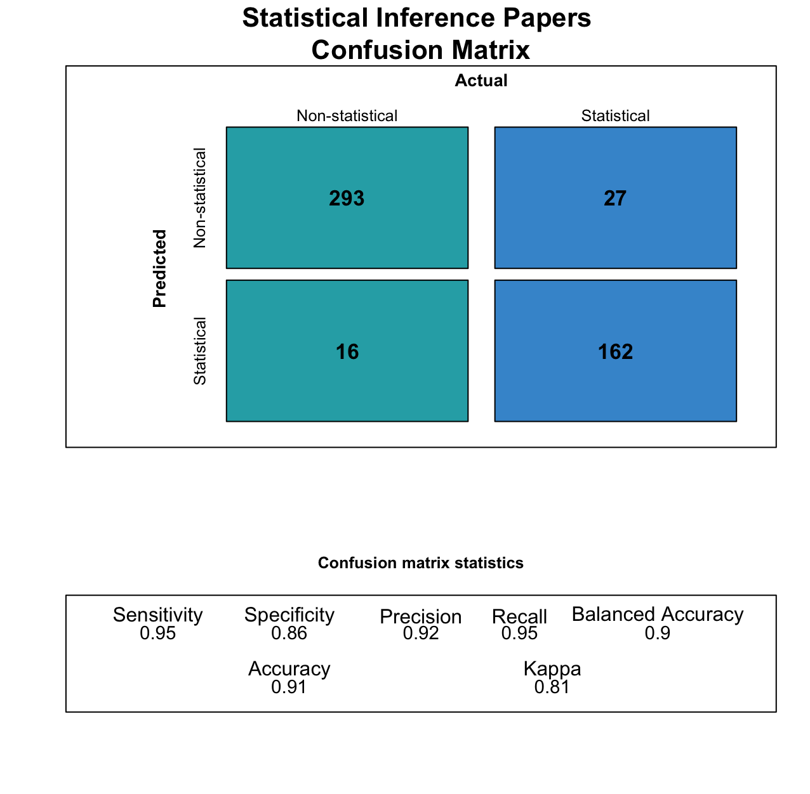

Figure 1 Support vector machine (SVM) confusion matrix for statistical inference paper classification.

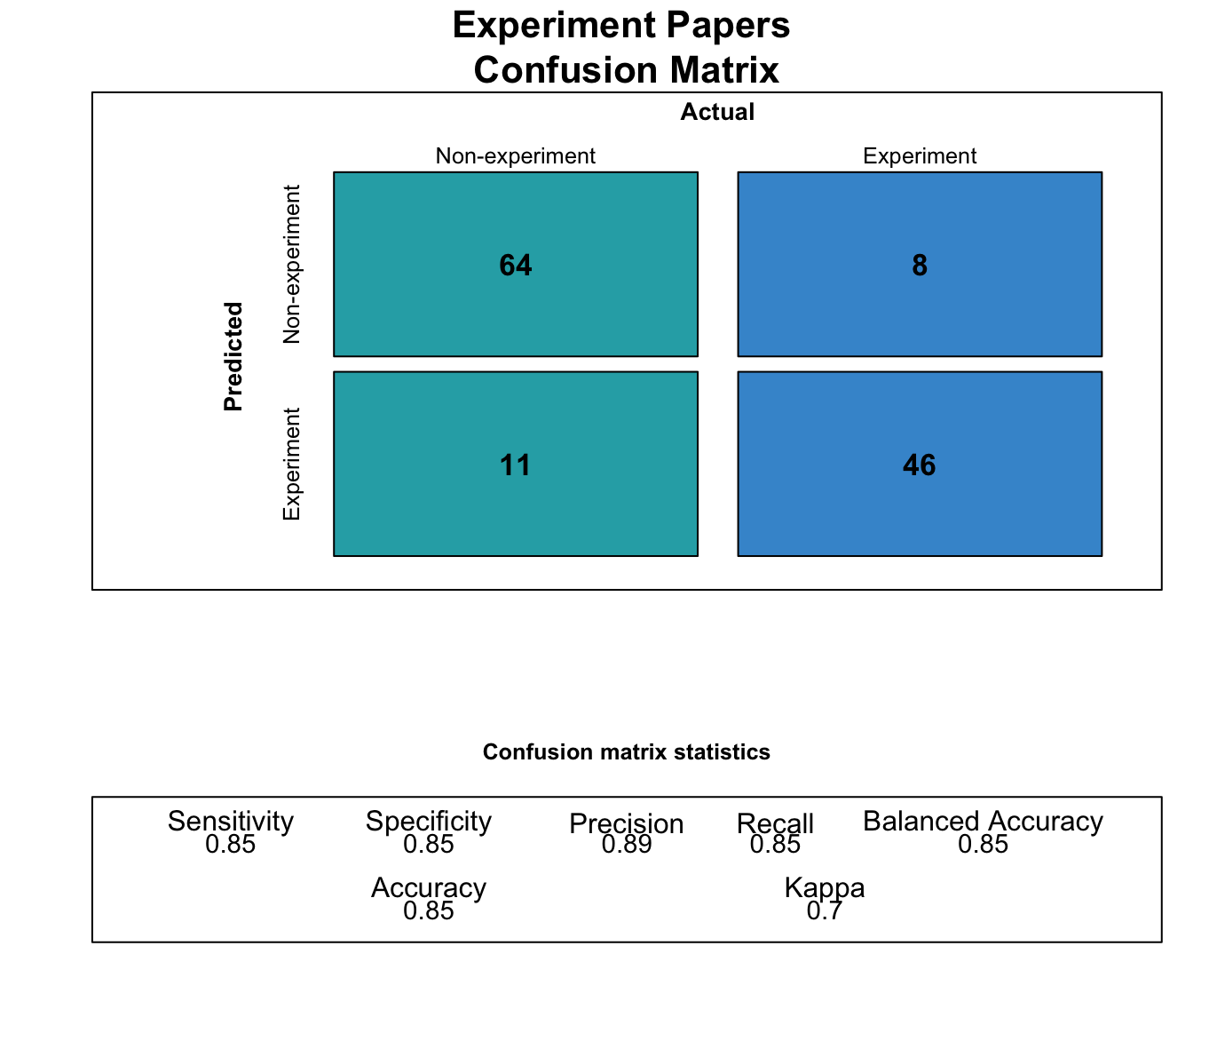

Figure 2 Support vector machine (SVM) confusion matrix for experiment paper classification.



Figure 3 Open data by journal.



Figure 4 Open data by journal.



Figure 5 Open data by journal (with over 20 statistical inference papers) in 2020.



Figure 6 Preregistration by journal.



Figure 7 Preregistration by journal in 2020.



Figure 8 Preregistration by journal (with over 5 experimental papers) in 2020.

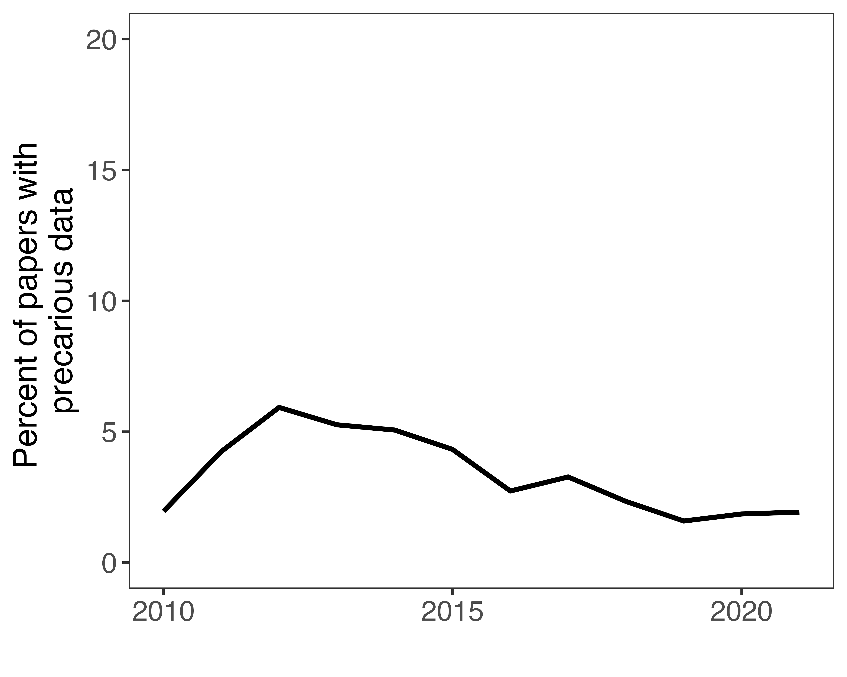

Figure 9 Precarious data by year.

## Identifying papers relying on data analysis

We defined data analysis papers as those that made any display or presentation of numerical data, most commonly in tables and graphs. Maps that included data-rich overlays and required software to produce were included in this category.